A Course Based Project Report on

**EXPENSE MANAGEMENT APPLICATION**

Submitted to the

**Department of CSE-(CyS, DS) and AI&DS**

in partial fulfilment of the requirements for the completion of course

**WEB TECHNOLOGIES LABORATORY (22PC2CS302)**

BACHELOR OF TECHNOLOGY

IN

**CSE-Data Science**

Submitted by

POOLA HANSINI 22071A6746

PUSULURI RACHANA CHOWDARY 22071A6748

RADHIKA REDDY MOTHE 22071A6750

SAKSHI ERUMALLA 22071A6752

Under the guidance of

**Dr. V. Radhika**

**Assistant Professor**



**Department of CSE-(CyS, DS) and AI&DS**

**VALLURUPALLI NAGESWARA RAO VIGNANA JYOTHI INSTITUTE OF ENGINEERING & TECHNOLOGY**

An Autonomous Institute, NAAC Accredited with ‘A++’ Grade, NBA

Vignana Jyothi Nagar, Pragathi Nagar, Nizampet (S.O), Hyderabad – 500 090, TS, India

**MAY 2025**

**VALLURUPALLI NAGESWARA RAO VIGNANA JYOTHI INSTITUTE OF ENGINEERING AND TECHNOLOGY**

An Autonomous Institute, NAAC Accredited with ‘A++’ Grade, NBA Accredited for CE, EEE, ME, ECE, CSE, EIE, IT B. Tech Courses, Approved by AICTE, New Delhi, Affiliated to JNTUH, Recognized as “College with Potential for Excellence” by UGC, ISO 9001:2015 Certified, QS I GUAGE Diamond Rated

Vignana Jyothi Nagar, Pragathi Nagar, Nizampet(SO), Hyderabad-500090, TS, India

**Department of CSE-(CyS, DS) and AI&DS**



**CERTIFICATE**

This is to certify that the project report entitled “**Expense Management Application**” is a bonafide work done under our supervision and is being submitted by **Poola Hansini (22071A6746), Pusuluri Rachana Chowdary (22071A6748), Radhika Reddy Mothe (22071A6750), Sakshi Erumalla (22071A6752)** in partial fulfilment for the award of the degree of **Bachelor of Technology** in **CSE-Data Science**, of the VNRVJIET, Hyderabad during the academic year 2024-2025.

**Dr. V. RADHIKA Dr.T.SUNIL KUMAR**

Assistant Professor Professor & HOD

Dept of CSE-(CyS, DS) and AI&DS Dept of CSE-(CyS, DS)and AI&DS

**Course based Projects Reviewer**

**VALLURUPALLI NAGESWARA RAO VIGNANA JYOTHI INSTITUTE OF ENGINEERING AND TECHNOLOGY**

An Autonomous Institute, NAAC Accredited with ‘A++’ Grade,

Vignana Jyothi Nagar, Pragathi Nagar, Nizampet(SO), Hyderabad-500090, TS, India

**Department of CSE-(CyS, DS) and AI&DS**



**DECLARATION**

We declare that the course based project work entitled “**EXPENSE MANAGEMENT APPLICATION**” submitted in the Department of **CSE-(CyS, DS) and AI&DS**, Vallurupalli Nageswara Rao Vignana Jyothi Institute of Engineering and Technology, Hyderabad, in partial fulfilment of the requirement for the award of the degree of **Bachelor of Technology in** **CSE-Data Science** is a bonafide record of our own work carried out under the supervision of

**Dr. V. Radhika, Assistant Professor, Department of CSE-(CyS, DS) and AI&DS , VNRVJIET.** Also, we declare that the matter embodied in this thesis has not been submitted by us in full or in any part thereof for the award of any degree/diploma of any other institution or university previously.

Place: Hyderabad.

|  |  |  |  |
| --- | --- | --- | --- |
| **Poola**  **Hansini**  (22071A6746) | **Pusuluri Rachana Chowdary**  **(**22071A6748) | **Radhika Reddy Mothe**  (22071A6750) | **Sakshi Erumalla**  (22071A6752) |

**ACKNOWLEDGEMENT**

We express our deep sense of gratitude to our beloved President, Sri. D. Suresh Babu, VNR Vignana Jyothi Institute of Engineering & Technology for the valuable guidance and for permitting us to carry out this project.

With immense pleasure, we record our deep sense of gratitude to our beloved Principal, Dr. C.D Naidu, for permitting us to carry out this project.

We express our deep sense of gratitude to our beloved Professor **Dr.T.SUNIL KUMAR**, Professor and Head, Department ofCSE-(CyS, DS) and AI&DS , VNR Vignana Jyothi Institute of Engineering & Technology, Hyderabad-500090 for the valuable guidance and suggestions, keen interest and through encouragement extended throughout the period of project work.

We take immense pleasure to express our deep sense of gratitude to our beloved Guide, **Dr.V.RADHIKA**, Assistant Professor in CSE-(CyS, DS) and AI&DS, VNR Vignana Jyothi Institute of Engineering & Technology, Hyderabad, for his/her valuable suggestions and rare insights, for constant source of encouragement and inspiration throughout my project work.

We express our thanks to all those who contributed for the successful completion of our project work.

Poola Hansini (22071A6746)

Pusuluri Rachana Chowdary (22071A6748)

Radhika Reddy Mothe (22071A6750)

Sakshi Erumalla (22071A6752)

**TABLE OF CONTENTS**

|  |  |  |
| --- | --- | --- |
| **CHAPTER** | **CONTENTS** | **PAGE NO.** |
|  | **ABSTRACT** | 2 |
| 1 | **INTRODUCTION** | 3 |
| 2 | **METHOD** | 4 |
| 3 | **TEST CASES/ OUTPUT** | 6 |
| 4 | **RESULTS** | 8 |
| 5 | **SUMMARY, CONCLUSION, RECOMMENDATION** | 10 |
|  | **REFERENCES** | 11 |

**ABSTRACT**

Managing shared expenses—whether for trips, outings, rent, or everyday bills—can often lead to confusion, miscommunication, and stress among groups. *Tally Mate* is a smart web application specifically designed to simplify this process, making group expense management more transparent, organized, and hassle-free. Whether you're traveling with friends, sharing a flat with roommates, or organizing a team event, Tally Mate offers a centralized platform to track, manage, and settle shared expenses without the usual headaches.

Built with modern technologies like the MERN stack (MongoDB, Express.js, React.js, Node.js), along with Firebase Authentication and Razorpay/PhonePe APIs for secure UPI transactions, Tally Mate brings two major capabilities to its users. The first is an advanced expense-tracking dashboard that functions like a smarter version of Splitwise. It provides real-time visualizations of income and expenses, highlights who contributes the most, monitors recurring payments, and offers actionable insights into group spending behavior. These features help maintain financial clarity and ensure that no one ends up overpaying or under-contributing.

The second core feature is the *Smart Split* system, which revolutionizes bill-splitting by offering multiple flexible options. Users can split expenses equally, assign custom amounts, or even divide itemized bills for more accuracy. To make settlements seamless, Tally Mate generates UPI QR codes for instant payments and sends automated reminders for any pending dues, eliminating the awkwardness of follow-ups. In short, Tally Mate aims to bring structure, fairness, and convenience to group financial interactions, helping everyone stay on top of their payments effortlessly.

**CHAPTER-1**

**INTRODUCTION**

In today’s rapidly evolving digital age, collaboration and shared experiences are more common than ever. From students sharing rental accommodations and splitting utility bills, to families planning vacations, friends organizing trips, or professionals coordinating events, the need to manage shared expenses has become a routine part of life. However, while the concept of sharing costs is simple in theory, in practice it often leads to confusion, disputes, and inefficiencies. Tracking who paid what, who owes whom, and how much everyone should contribute can quickly become a source of frustration, especially in larger groups or over extended periods of time. Traditional methods such as spreadsheets, messaging apps, or manual note-taking are not only cumbersome but prone to human error and lack real-time synchronization.

This is the problem space that **Tally Mate** aims to address. Tally Mate is a comprehensive web-based application designed to simplify and streamline the management of shared expenses among groups. It empowers users to collaborate financially without the stress and hassle typically associated with expense tracking. By providing an intelligent and transparent system, Tally Mate removes ambiguity and fosters financial harmony within groups, whether among roommates, travelers, friends, or colleagues.

At the heart of Tally Mate are two powerful features: a smart **expense-tracking dashboard** and a **flexible bill-splitting engine**. The dashboard provides users with real-time insights into group finances, including a breakdown of income and expenses, visual analytics, individual contributions, and recurring transactions. This helps users maintain a clear picture of their shared financial situation at all times. The bill-splitting engine complements this by allowing users to divide expenses in multiple ways—equally, by percentage, through custom amounts, or even item-wise. This flexibility ensures that contributions reflect actual usage or agreement, leading to more fair and precise settlements.

Tally Mate is built using the **MERN stack**—MongoDB, Express.js, React.js, and Node.js—a combination of technologies known for their scalability, responsiveness, and efficiency in web application development. For user authentication and data security, the platform utilizes **Firebase Authentication**, ensuring robust login mechanisms and user data protection. Moreover, to facilitate real-time, secure transactions, Tally Mate integrates with **UPI payment gateways** such as **Razorpay** and **PhonePe**, enabling instant settlement through dynamically generated QR codes and direct UPI transfers.

What truly distinguishes Tally Mate from other expense-sharing tools is its emphasis on intelligent automation and user-centric features. The application automatically generates monthly and group summaries, sends timely reminders for pending payments, and identifies patterns such as frequent contributors or recurring costs. These smart insights not only reduce the need for constant manual tracking but also foster a greater sense of accountability and fairness within the group. Users can quickly identify outstanding dues, understand their spending habits, and resolve any discrepancies with minimal friction.

In addition, the platform supports a **centralized group expense history**, so users can revisit past transactions and see a transparent log of who paid what, when, and for what purpose. This transparency goes a long way in preventing conflicts and misunderstandings that are common in shared financial situations. With its sleek interface, ease of use, and depth of functionality, Tally Mate is designed for both casual users managing short-term expenses and long-term users coordinating ongoing group budgets.

In essence, Tally Mate is more than just a tool—it is a financial companion built to bring **structure, clarity, and peace of mind** to shared monetary responsibilities. It alleviates the social awkwardness of asking for money, helps eliminate errors in calculations, and promotes responsible financial behavior among groups. By reducing the administrative burden and introducing automation where it matters, Tally Mate allows users to focus on their relationships, activities, and goals, rather than the intricacies of who owes whom.

As digital transactions and group activities continue to rise, the relevance of platforms like Tally Mate becomes ever more pronounced. Through its innovative design and user-focused features, it represents a new standard in group expense management—**smart, secure, and stress-free**.

.

**CHAPTER-2**

**METHOD**

The development of Tally Mate followed a structured, multi-phase methodology aimed at building a smart, user-friendly, and secure web application for managing group expenses. The goal was to ensure real-time collaboration, flexible expense tracking, and seamless UPI-based settlements. This chapter details the methods followed during the planning, design, development, integration, and testing phases of the application.

1. Technology Stack Selection

The first and most crucial step was selecting a robust and scalable technology stack. Since the app was expected to handle dynamic data, real-time interactions, and secure financial transactions, we opted for the MERN stack—MongoDB, Express.js, React.js, and Node.js.

MongoDB was chosen for its schema-less structure, allowing flexibility in storing expenses, groups, users, and transaction data. It supports efficient queries and scales easily.

Express.js provided a fast and minimalist backend framework for routing, middleware, and APIs.

React.js enabled the creation of a responsive, component-based user interface with fast updates.

Node.js served as the backend runtime, handling asynchronous operations efficiently.

For authentication, we used Firebase Authentication, which provided secure login/signup with minimal setup and support for features like email verification and session persistence.

To facilitate UPI transactions, Razorpay and PhonePe APIs were integrated, offering secure and instant digital payment capabilities, including QR code generation and transaction tracking.

2. Frontend Development

The frontend is the user-facing side of Tally Mate and was developed using React.js. A responsive and intuitive design was key to ensuring user adoption and ease of use.

Component Architecture: We created modular and reusable components such as ExpenseForm, GroupDashboard, SplitOptions, PaymentStatus, and TransactionHistory. This made development faster and code more maintainable.

Real-time UI Updates: Using useEffect hooks and conditional rendering, we ensured that whenever a transaction or expense was updated, the dashboard reflected the change immediately.

Data Visualization: Libraries such as Chart.js were used to create graphs showing group contributions, payment history, and spending trends.

Responsive Design: CSS Flexbox and media queries ensured the layout adapted seamlessly to desktops, tablets, and mobile phones.

We focused on user-centric design principles, ensuring that even non-technical users could easily navigate and perform actions such as adding expenses, sending reminders, or scanning UPI QR codes.

3. Backend Development

The backend, powered by Node.js and Express.js, handled all server-side logic, API requests, database operations, and integrations.

Key functionalities included:

User Management: Handling authentication via Firebase, user sessions, and permission checks.

Expense Management APIs: Creating, updating, deleting, and retrieving expenses; supporting multiple split modes.

Group Logic: Creating groups, assigning members, and managing shared records.

Transaction Management: Tracking payments, settlement statuses, and generating QR codes through UPI API calls.

Analytics & Summaries: Generating monthly reports, contribution breakdowns, and group spending insights.

Middleware was used for validation, error handling, and token verification. Each API route was tested individually using tools like Postman during development.

4. Bill Splitting Mechanism

One of the standout features of Tally Mate is its flexible Smart Split system, offering several splitting modes:

Equal Split: Automatically divides the bill evenly among group members.

Custom Split: Allows users to input specific amounts for each member.

Itemized Split: Lets users assign specific items or costs to individuals for more accurate calculations.

Behind the scenes, we used algorithms to calculate each user's share, considering who paid initially and how much each person owes. These amounts were stored in the database and used to generate settlement suggestions and QR codes.

5. UPI Integration and Payment Tracking

To facilitate real-time, cashless settlements, we integrated Razorpay and PhonePe UPI APIs.

UPI QR Code Generation: When a user initiates a payment, a dynamic QR code is generated that encodes the payee's UPI ID, amount, and remarks.

Transaction Verification: After scanning the QR, users are redirected to their UPI app. The backend awaits confirmation from Razorpay or PhonePe servers.

Status Monitoring: Payment status (paid, pending, failed) is updated in real time and reflected in the group dashboard.

This eliminated the need for manual confirmations and helped users settle dues instantly, reducing the friction commonly seen in shared expenses.

6. Notification & Reminder System

One of the common issues in group expenses is delayed payments. To mitigate this, we implemented:

Automated Reminders: Scheduled messages (via email or in-app notifications) to remind users of pending dues.

Push Notifications: Alert users instantly when someone adds a new expense, makes a payment, or updates their share.

Monthly Summaries: Generated and sent at the end of each month showing how much the user paid, owed, and the group’s overall expenses.

Firebase Cloud Messaging and backend cron jobs were used to automate these reminders.

7. Real-Time Dashboard

The dashboard is the heart of the user interface, designed to provide an at-a-glance view of all group financial activity.

Key components include:

Total Income & Expenses

Contribution Leaderboard (who paid the most)

Pending Settlements

Spending Categories (food, travel, rent, etc.)

Recurring Expenses like subscriptions or rent

We used MongoDB’s aggregation framework to calculate totals, averages, and recurring patterns. Updates to the dashboard occur in near real-time as users add or edit expenses.

8. Testing and Security Measures

Throughout the development cycle, rigorous testing ensured reliability and robustness:

Unit Testing: Each function and API endpoint was tested independently.

Integration Testing: Ensured that backend and frontend worked seamlessly, especially for critical flows like login → add expense → pay via UPI.

User Testing: Conducted with a sample group to gather feedback on usability, design, and bugs.

Security Practices:

Firebase Authentication guarded all sensitive operations.

HTTPS was enforced across all routes.

User data and transactions were encrypted during storage and transmission.

Backend endpoints included rate limiting and input validation to prevent abuse.

By following industry best practices, Tally Mate maintains data integrity, user privacy, and financial security.

This method ensures that "TallyMate" provides an easy-to-use, secure, and reliable platform for managing group expenses, with added features that make the process smoother and more organized.

**CHAPTER-3**

**TEST CASES/ OUTPUT**

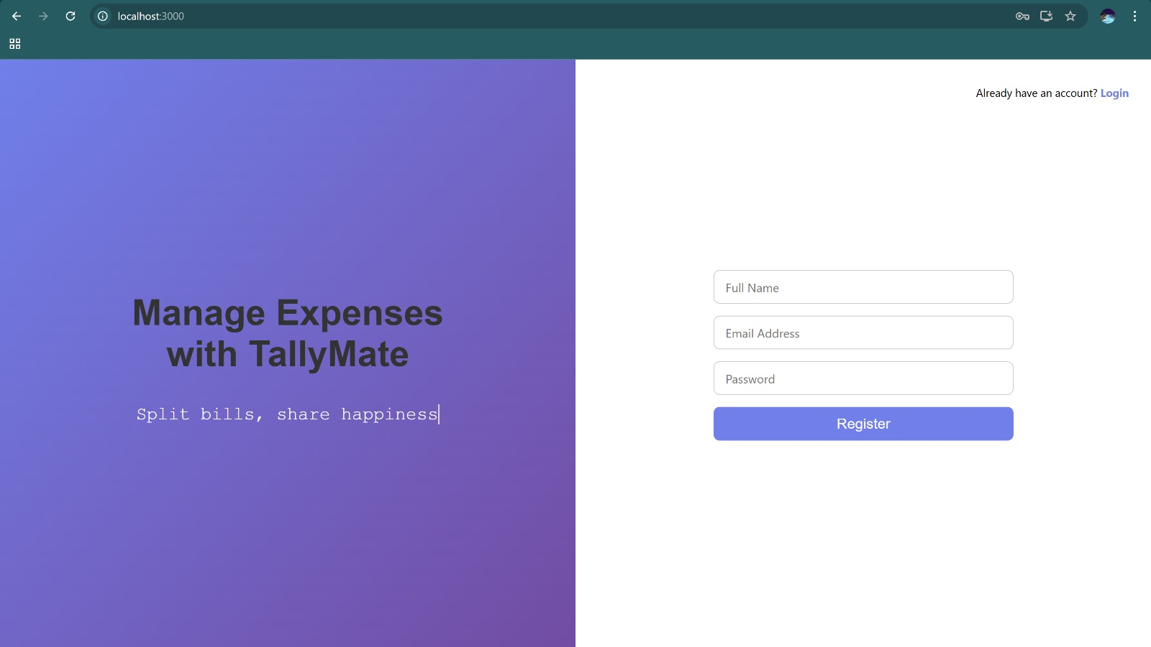

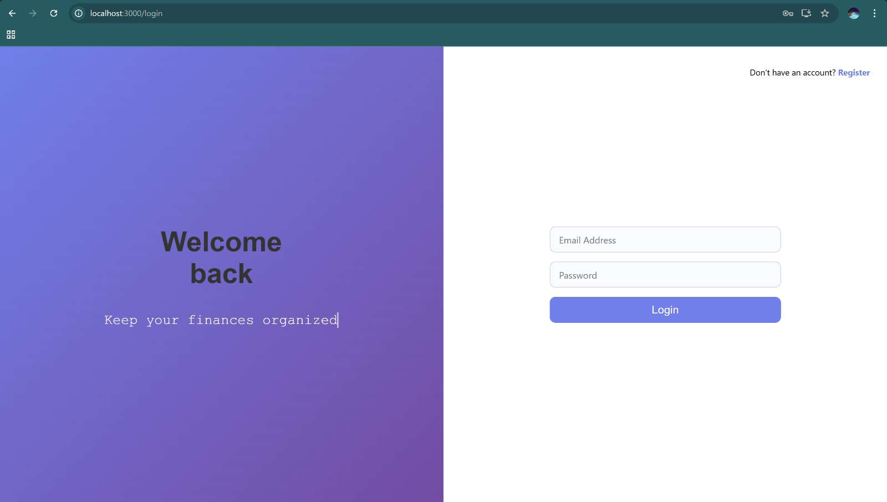

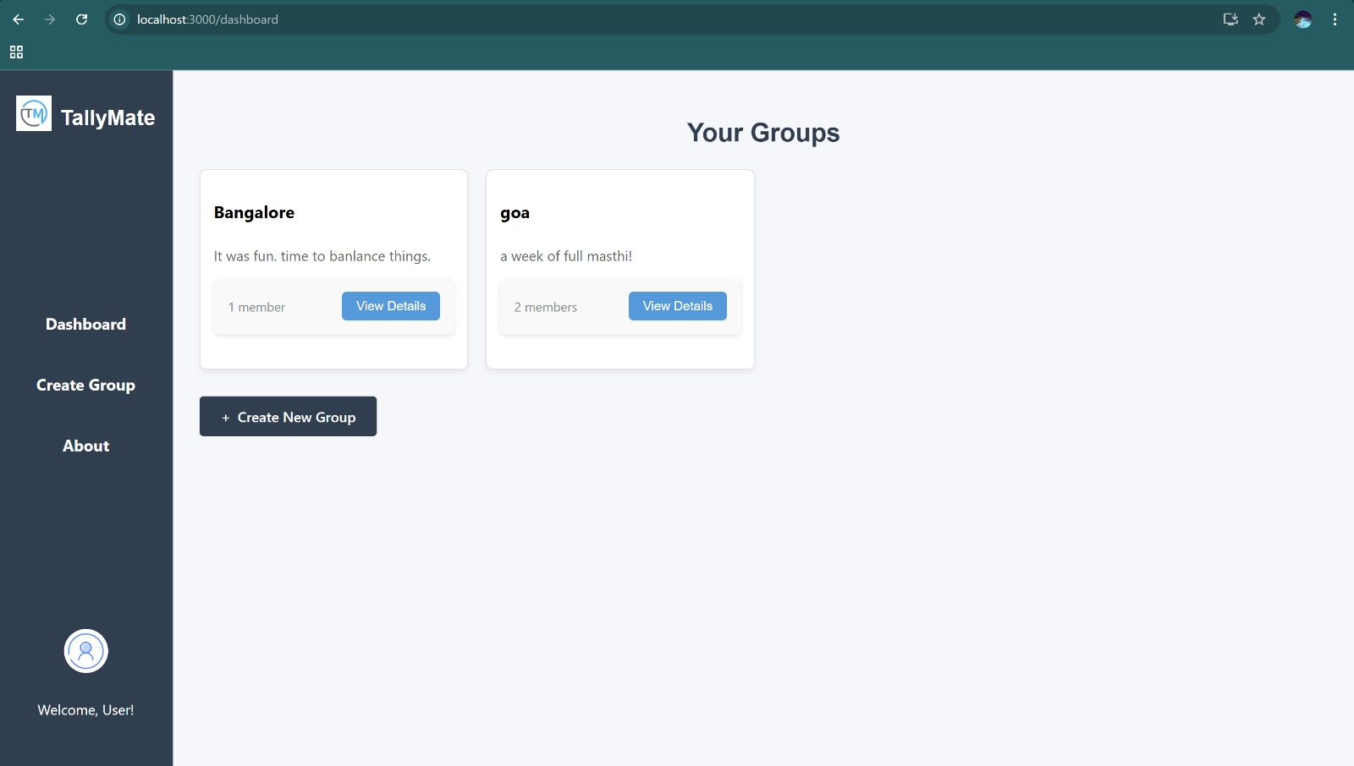

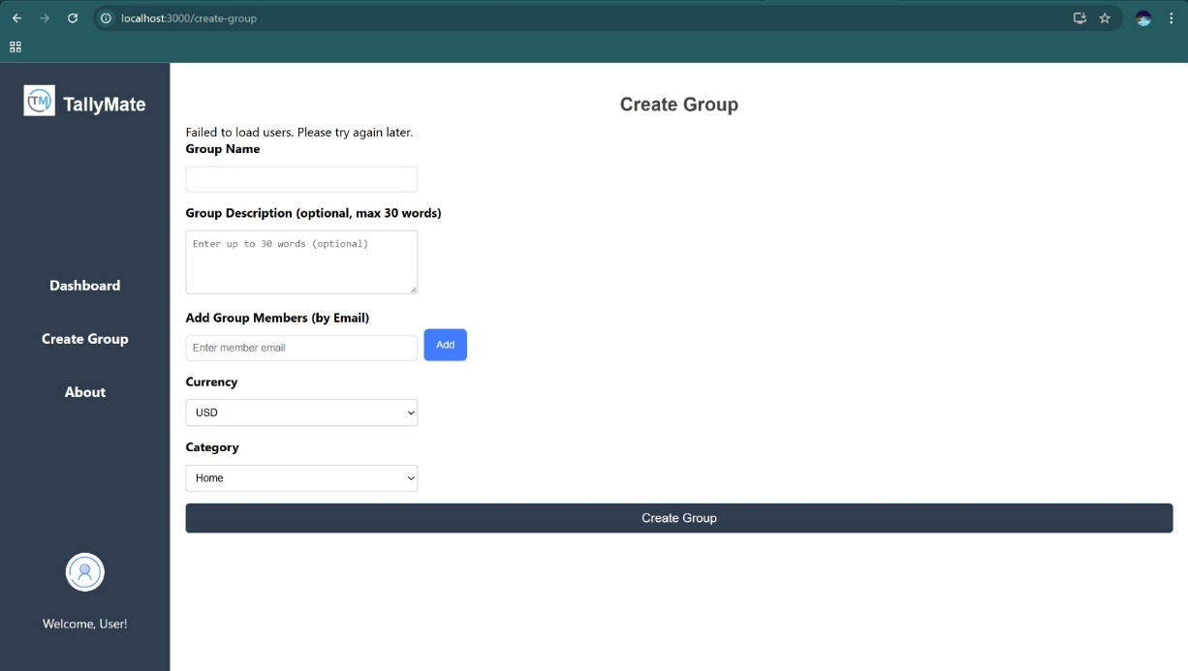

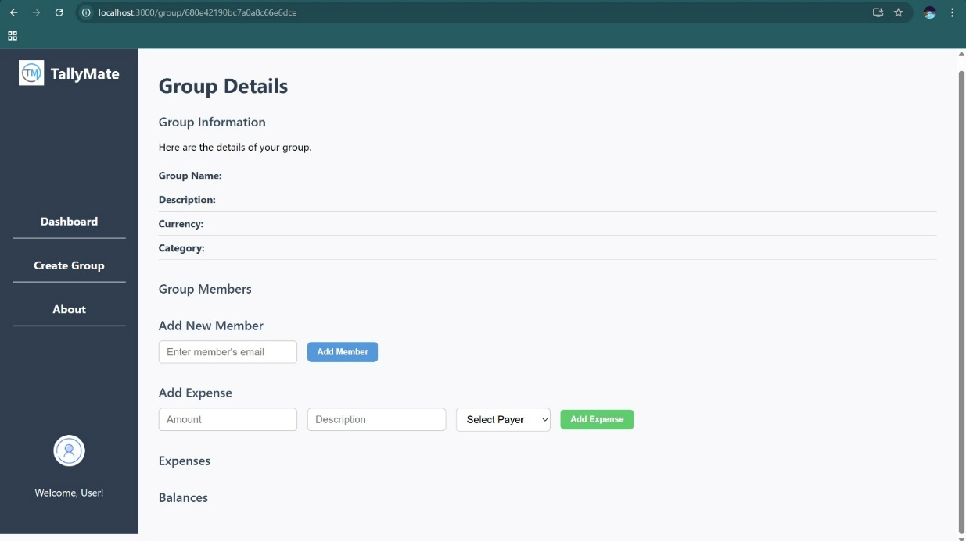

**CHAPTER-4**

**RESULTS**

The core functionalities of the **Tally Mate** application were theoretically evaluated based on key features such as registration, login, bill splitting, payment tracking, notifications, and dashboard updates. These results will be complemented with real screenshots after deployment.

**1. User Registration**

* **Result**: Users can register successfully with valid email and password credentials.
* **Observation**: Firebase Authentication securely handles user credentials, and users are redirected to the login page upon successful registration with a confirmation message.

**2. User Login**

* **Result**: Registered users are able to log in and access the dashboard.
* **Observation**: The login process is smooth and secure, authenticated by Firebase, with success feedback displayed.

**3. Smart Bill Splitting – Equal Split**

* **Result**: Expenses are evenly divided among all group members.
* **Observation**: The equal split algorithm ensures accurate calculation and fair distribution of the total amount.

**4. Smart Bill Splitting – Custom Split**

* **Result**: Users can define custom payment shares per member.
* **Observation**: The feature supports flexible, user-defined splits for various types of shared expenses such as meals, groceries, or utilities.

**5. Payment Tracking with UPI Integration**

* **Result**: Payments made via UPI (Razorpay/PhonePe APIs) are successfully processed and recorded.
* **Observation**: Secure integration with payment gateways allows users to view transaction history and outstanding balances.

**6. Payment Reminder Notifications**

* **Result**: Users receive timely reminders about pending or upcoming payments.
* **Observation**: The notification system is effective in promoting timely settlements and reducing manual follow-ups.

**7. Real-Time Income-Expense Dashboard**

* **Result**: The dashboard updates live to reflect current transactions and expenses.
* **Observation**: Users gain visibility into spending patterns, frequent contributors, and recurring costs, enhancing financial transparency.

**CHAPTER-5**

**Summary, Conclusion, Recommendation**

**TallyMate** is a modern web application built using the MERN stack (MongoDB, Express.js, React.js, Node.js) aimed at simplifying group expense management. With features like smart bill splitting, UPI-based payment tracking, real-time dashboards, and automated reminders, it allows users to manage shared financial responsibilities efficiently. The integration of Firebase Authentication ensures secure user access, while Razorpay and PhonePe APIs enable seamless payment transactions. Designed for everyday scenarios like trips, rent sharing, and outings, TallyMate eliminates confusion in group payments and promotes financial transparency.

Theoretical evaluations of the application indicate that all core functionalities—such as equal and custom bill splitting, real-time dashboard updates, secure login, and payment reminders—perform as intended. The interface is user-friendly, making it easy for individuals to track contributions, view payment summaries, and stay informed about their dues. The backend processes payments reliably, and the front end offers a smooth, interactive experience. The notification system also functions effectively, reducing delays in settlements by keeping users informed of their obligations.

Looking ahead, TallyMate can benefit from enhancements such as expanding payment gateway options (e.g., Google Pay, Paytm), introducing a mobile app for better accessibility, and offering deeper financial insights through advanced analytics and visualizations. Additional features like multi-currency support, two-factor authentication, and customizable group tagging could broaden its appeal and improve usability. With live deployment, user testing, and continuous feedback loops, TallyMate has the potential to evolve into a go-to platform for smart, reliable, and secure group expense management.

**REFERENCES**

1. Nielsen, J., & Molich, R. (1990). Heuristic evaluation of user interfaces. In Proceedings of the SIGCHI Conference on Human Factors in Computing Systems (pp. 249-256). ACM.
2. <https://www.npci.org.in/what-we-do/upi>
3. <https://www.techrepublic.com/article/understanding-the-mern-stack-mongodb-express-react-node-js/>
4. <https://www.forbes.com/sites/forbestechcouncil/2020/05/07/why-every-business-needs-a-mobile-app-for-customer-engagement/>
5. <https://www.kaspersky.com/blog/protect-mobile-payments/>
6. Nielsen, J. (2012). *Usability Engineering*. Morgan Kaufmann. <https://www.nngroup.com/articles/definition-user-experience/>